**St James’ Pre-School Newsletter**

Issue 3 January 2016

Welcome to our January edition of the Newsletter.

Thank you to everyone for your fantastic support over the Christmas period.

Why not relive your child’s wonderful performance in our Nativity Play by buying a **Nativity DVD**. These are now on sale at a cost of £3 each.

C:\Users\User\AppData\Local\Microsoft\Windows\Temporary Internet Files\Content.IE5\VL7RZQ6C\MC900155072[1].wmf

The **Christmas bazaar** was a great success, raising £669.46. **Thank you** to all the committee members and parents who helped in many practical ways to create such an enjoyable and profitable event. And thank you to everyone who dug deep to buy cakes, toys, books, raffle tickets and much more on the day. Everyone was very generous. St James’ Pre-School relies on fundraising events and activities so your support is vital and very much appreciated.

**Staff News** We look forward to welcoming **Kelly** back after her maternity leave. Kelly will be returning on 1st February to join the **Green group** as a Key Person. The children in the Green group enjoyed meeting Kelly, and baby Freddie, when they visited us recently.

**Morning Registration**

May we ask for your help at this busy time of the morning.

Please follow the **ONE WAY SYSTEM** when registering your children (entering by the main entrance and leaving through the door at the end of the corridor by the parent and toddler hall). The system is in place for health and safety reasons and staff members may have information for you at the **back door** such as tickets for up and coming events or book selections. This is also an opportunity for parents and carers to give information to staff, perhaps concerning changes in collection arrangements for a child that day.

**FUNDRAISING ACTIVITIES AND EVENTS**

St James Pre-School is a non-profit organisation and we rely heavily on fundraising so we would welcome your support for the following activities and events.

**Half Term Fundraising Disco**

C:\Users\User\AppData\Local\Microsoft\Windows\Temporary Internet Files\Content.IE5\97R8GEBX\MC900391024[1].wmf

We will be holding a fundraising **disco** on **Friday 12th February** from 12.15 until 2pm. Children can wear their own party clothes to Pre-School for the day. Tickets priced **£2** will be on sale shortly. The children will be entertained by the ever popular **WOODY**. Refreshments will be available; hot dogs and juice drinks for the children and tea, coffee and cakes for the adults.

Any donations of **cakes** would be very welcome. Please bring these in on the morning of the disco.

We will also be holding a Raffle on the day and tattoos, face paints and a nail bar will all be available. Please come and join us. You will have a great time!

If you are available to help at the Disco or to sell raffle tickets in the queue at the end of the morning, please let Deb or Marion know. We would be most grateful for any help!

**Bags for School**

Please start collecting unwanted good quality clothing, paired shoes, books and bric-a-brac for a bag collection which will benefit both **Claire House** and Pre-School. Bags will be issued to the children nearer the date for collection on **Friday 11th March** when filled bags can be brought to Pre-School. This was a very successful fundraiser for us last term and it is a good opportunity to support Claire House too.

**Thank you for your support.**



**World Book Day**

We are looking forward to World Book Day on **Thursday 3rd March**. Children are invited to attend Pre-School that day dressed as their favourite character from a book.

**DATES FOR YOUR DIARY** 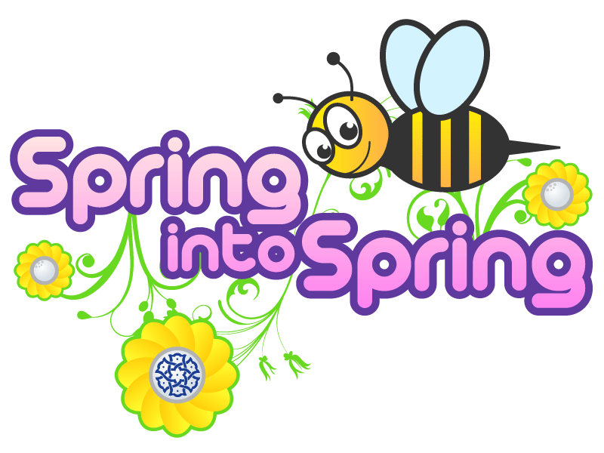

* Half Term Disco **Friday 12th February**
* Pre-School closes for **HALF TERM** on **Monday 15th February** (Children’s last day Friday 12th February) and the children return to Pre-School on **Monday 22nd February.**
* World Book Day **Thursday 3rd March**.
* Claire House Bags for School collection **Friday 11th March.**
* Easter Hat Parade **Friday 18th March.**
* Pre-School will be closed for the Easter weekend on **Good Friday 25th March** and **Easter Monday 28th March.** Children return to Pre-School on **Tuesday 29th March.**
* Pre-School closes for **SPRING BREAK** on **Monday 4th April** (Children’s last day Friday 1st April) and the children return to Pre-School on **Tuesday 19th April**

More information about **Easter activities**, including the Easter Hat Parade, will be given in our next Newsletter.

Deb, Marion and all the staff team would like to thank you for reading this newsletter.

We are grateful for your support as always.

**St James’ Pre-School Ltd.**

*A non profit organisation*

Charity Number 1160217

Phone: 0151 428 7525

Email: [stjamespreschool@hotmail.com](mailto:stjamespreschool@hotmail.com)

Website: stjamespreschoolwoolton.com