St James’ Pre-School Newsletter
Welcome to our June 2023 edition of the Newsletter.
Fundraising news
A huge thanks to all who supported our Summer Disco, with your generous contributions we raised a fantastic £269.70.
Thank you to everybody for taking part in our Sponsored colour. The children were very creative with their designs for the Sunflowers. We loved having them on display and the children loved showing off their pictures to their friends. The total collected for our sponsored colour was £376.20 from Preschool and £236.00 from the Parent & Toddler Group. Thanks again.
The last Roberts Recycle Collection raised £48.40 bringing the total for the year to £149.60.
Thank you for your continued support.
We had good news from the Woolton Education Grant, our application was successful. We will be purchasing a new rocker/steps, some large water play resources and a magnetic wedge board.
St James’ Pre-School relies heavily on fundraising activities and events and the staff team would like to take this opportunity to thank all the families and friends who have generously supported us throughout the year.
Summer Term News
It has been a very busy term for us all. We celebrated the Coronation of King Charles with a party, we had hoped to hold it outside, but the weather was a little unkind on the day, the children still enjoyed it. As the Eurovision Song contest was being hosted in Liverpool we could not miss the opportunity to make a day of it in Preschool. The children were invited to come dressed as a Rock star, they had a morning of musical fun with instruments, singing, a stage, drum kit, guitar and a giant floor piano, we even listened to different genres of music….it made a change from singing nursery rhymes. We had Walk to School week, the children loved sharing their observation sheets and chatting about the different things they observed on the way to preschool. During healthy eating week the children prepared some of their own snacks, learning to chop, spread, cut and mix ingredients. They then got to eat their own creations, these included smoothies, banana muffins, watermelon pizza and sandwiches. We always find the children seem to enjoy the food and are more willing to try it when they have helped to make it themselves.
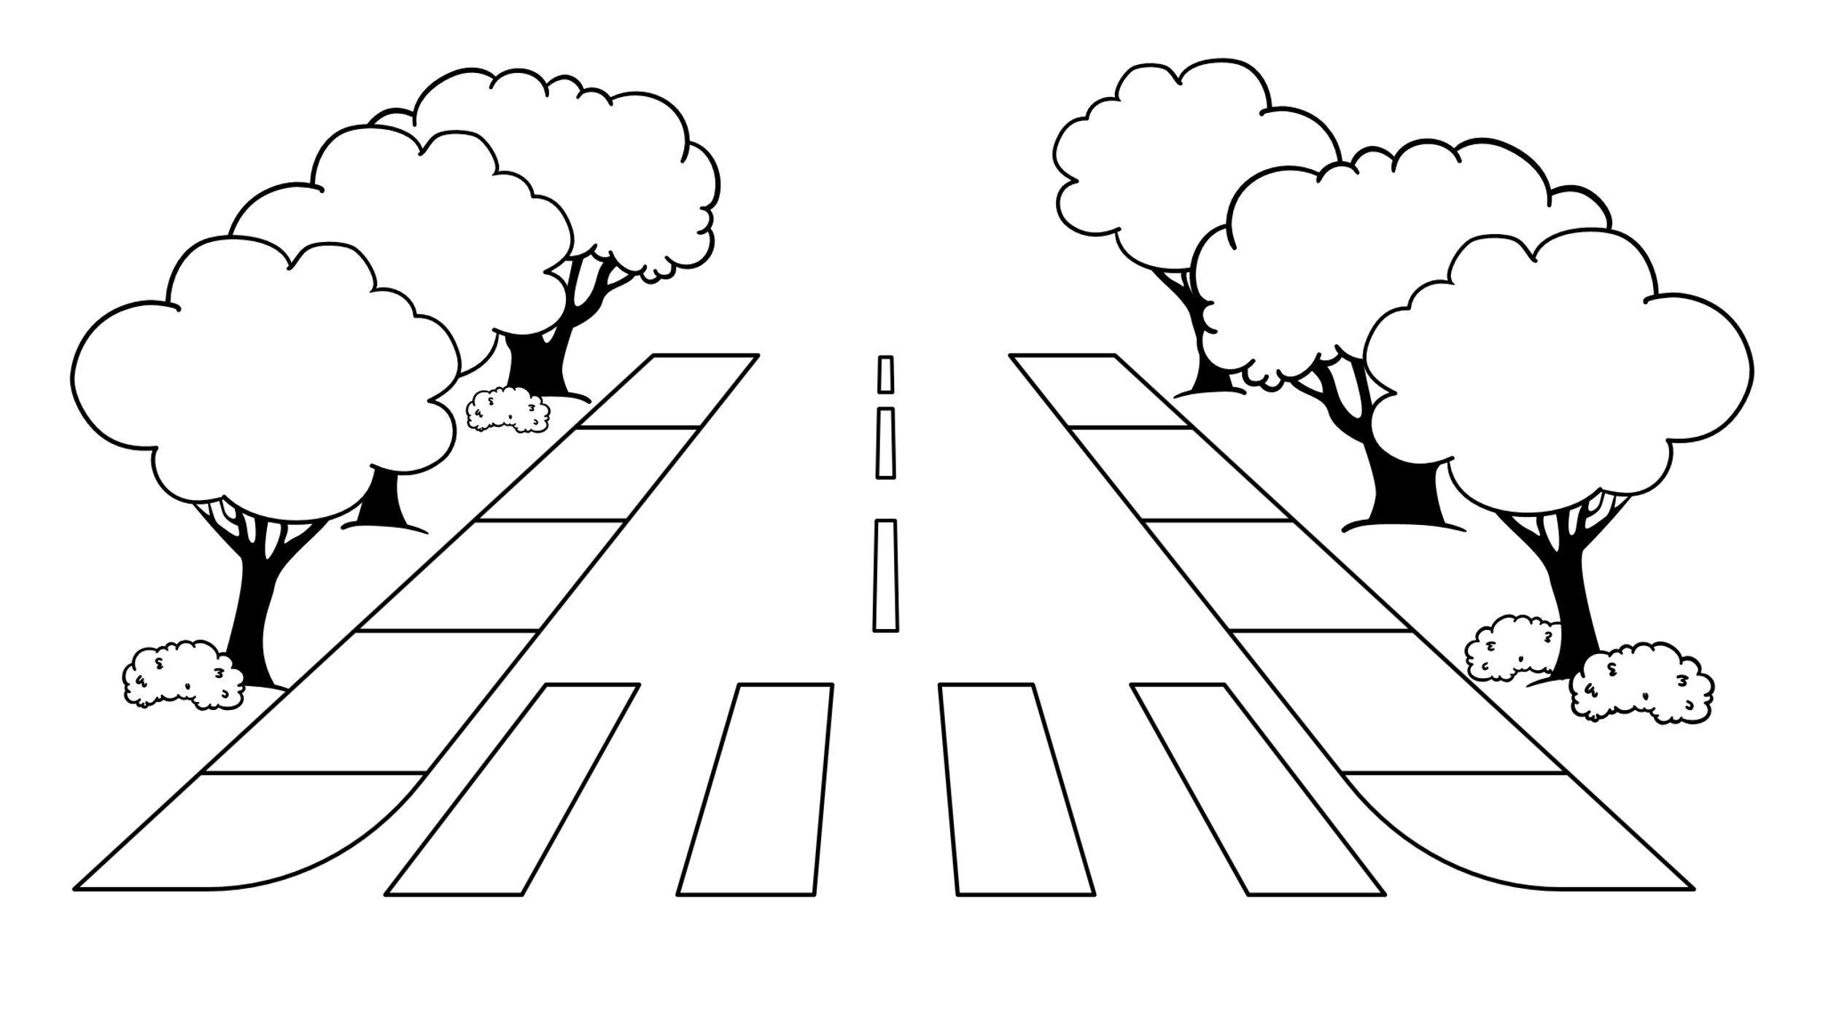
Those children who are leaving Pre-School to start Reception had a group photograph taken on Monday 22nd May. They enjoyed dressing up in graduation outfits, we hope you like the photographs.
Transition reports for children starting school have all been completed and sent out to schools. Assessments for all children have been posted on the FAMLY app.

End of Term arrangements
We would like to invite parents of children who are leaving us to start ‘big school’ to come to our Leaver’s Concert on Monday 17th July in St James’ Church at 12.30. Invitations from the children have been sent out. The staff team will be taking the older children over to church and we look forward to seeing you there. Be sure to have your tissues handy! If your child is not leaving us to start reception in school, please collect them as usual at 12.15.
Wednesday 19th July is our last day of the school year and our end of term Summer party, with games, dancing and party food. This will start at 9.15 and finish at 11.15. All pre-school children are welcome to come to the summer party whether they usually attend on a Wednesday or not and are welcome to wear their best party clothes! Please let us know if your child will be coming to the party and pay any additional fee, if appropriate, in a named envelope in advance. Thank you for your support.
Good Luck to all our children leaving for big school. It has been lovely to have your company and we will miss you all.

NEWS FOR CHILDREN RETURNING TO PRE-SCHOOL IN SEPTEMBER
Fee Increase from September 2023

Due to an increase in running costs, our daily fee will be increased from £15.00 a session to £18.00 a session from September 2023.
Following a consultation at a recent Trustees meeting, a charge of 50 pence per session as a contribution towards our mid morning snack will be introduced. We provide a variety of healthy, nutritious snacks every day and incorporate snacks from different cultures in line with celebrations/special events. We’d suggest that parents who pay fees, add the charge for snack to the daily fee and so pay £18.50 per session. Parents in receipt of Early Years funding could pay weekly, 4 weekly or half termly if this is more convenient. Please don’t hesitate to speak to Deb or Suzanne if you have any concerns.
The administration fee will remain at £75 a year and this can be paid in three instalments of £25 at the beginning of each term. The administration fee is payable by all children including those in receipt of nursery funding.
Payments can be made in cash or by online bank transfer (bank details can be provided on request.) If paying in cash, money MUST be placed in an envelope and must include your child’s name and details of the payment. Envelopes are available at the front desk so please feel free to take one.
Also during the recent Trustee meeting a discussion took place about the possibility of offering a Breakfast club from 8.30 a.m. This is still under consultation but we would welcome any feedback or interest from parents of returning/new children.

Dates for your Diary

- Leaver’s Concert: Monday 17th July in St James’ Church at 12.30. The children involved in the concert will be taken over to Church by staff members and we hope that the concert will start as near to 12.30 p.m. as possible. Children not involved in the Leavers’ concert should be collected at 12.15 as usual.
- Summer Party and last day of term: Wednesday 19th July from 9.15 to 11.15. Please collect all children at 11.15 on this day.
- Children return to Pre-School on Monday 4th September
- AGM – Thursday 19th October at 7.45p.m.
Term dates for the next school year (September 2023-July 2024) are attached to the newsletter and also available on our Website & FAMLY app.

This is our last Newsletter before the summer break, so the staff team at St. James’ would like to wish everyone a happy holiday and thank you for your support throughout the year.
Thank you for reading this newsletter!
St James’ Pre-School Woolton Ltd. A non profit organisation Charity Number 1160217
Phone: 0151 428 7525
Email: stjamespreschool@hotmail.com
Website: stjamespreschoolwoolton.weebly.com

